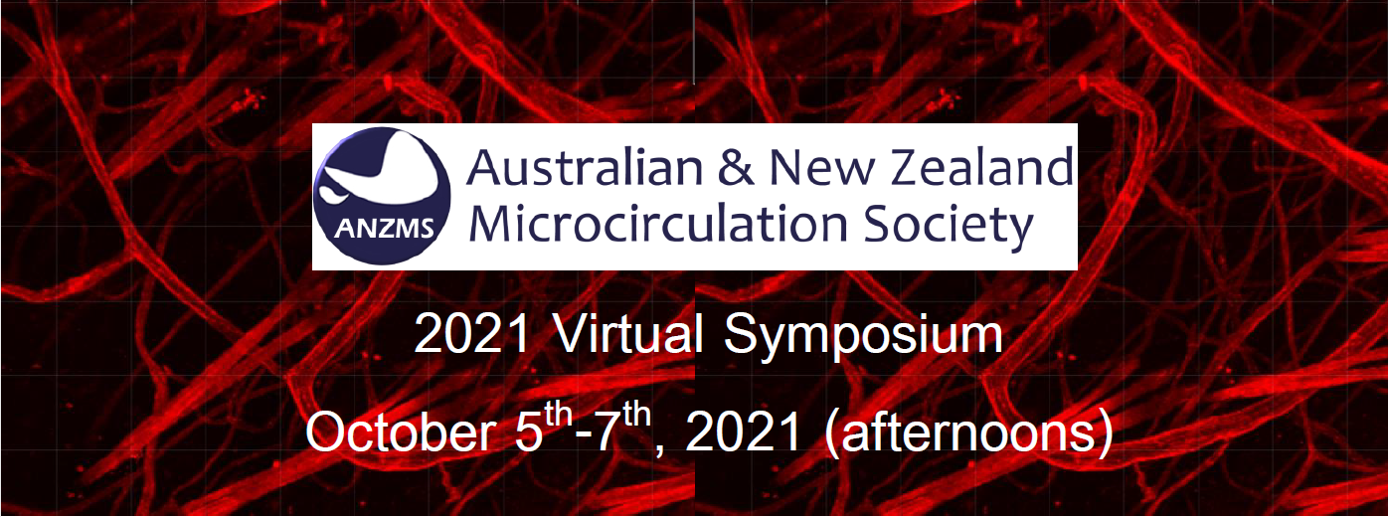

ABSTRACT PREPARATION INSTRUCTIONS

- Closing Date for Abstract submission: September 17th, 2021
- Prepare Abstract in MS Word or equivalent to fit on one page
- Use 12-point Times New Roman Font
- Page margins 2.5 cm on all sides
- Graphs and figures can be included assuming that the entire abstract fits onto a single page
- Use the following format. Presenting Author’s name should be underlined
- Submit Abstract via email to ANZMS Secretary Dr Maria Jelinic (m.jelinic@latrobe.edu.au) ON OR BEFORE CLOSING DATE – September 17th, 2021

SAMPLE ABSTRACT

MIF IS A FUNCTIONAL LIGAND OF CXC CHEMOKINE RECEPTORS IN INFLAMMATORY AND ATHEROGENIC CELL RECRUITMENT
Daniel Andrews¹, Gladys Berejiklian², Marc McGowan¹
From: ¹ Centre for Inflammatory Diseases, Monash University, Vic., 3168 1, and ² Department of Pharmacology, University of Western Australia

Start abstract here using 12 point Times New Roman Font and fit all material on to a single A4 page (2.5 cm margins on all sides), including figures.

Scientific Session of Interest for Submitted Abstract:

☐ Inflammation and the microvasculature/microvascular pathology

☐ Control of Vascular Tone

☐ Microvascular adaptations in pregnancy and perinatal outcomes

☐ Extracellular Vesicles (EVs) and the Microcirculation

☐ Cerebrovascular Biology

☐ Vascular Remodeling / Smooth Muscle / Angiogenesis

Consideration for Scientific Sessions Prizes

In order to be eligible for prizes at the ANZMS 2021 Symposium, please tick the box below to indicate whether you are a student or an ECR:

☐ Are you a Higher Degree Research student (i.e. Honours / Masters / PhD)?

☐ Are you an Early Career Researcher (i.e. PhD conferred within last 10 years)?

